Test Case: tc002_SPX_Dev5_Crear_Requisicion_Spot_Tipo_Cobro_Project
Step 1 - Enter username and password and click to button Enter: Credentials Entered
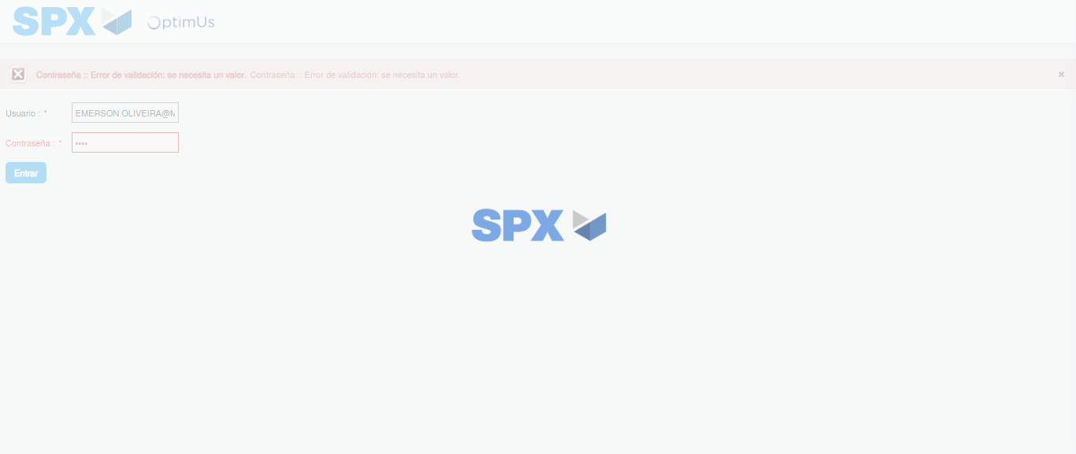Image file-name: QC_Testing-tc002_SPX_Dev5_Crear_Requisicion_Spot_Tipo_Cobro_Project-1785974718666

Step 2 - Select to UEN and Access to Spot Buy Requisitions : UEN Correctly selected and Correct access
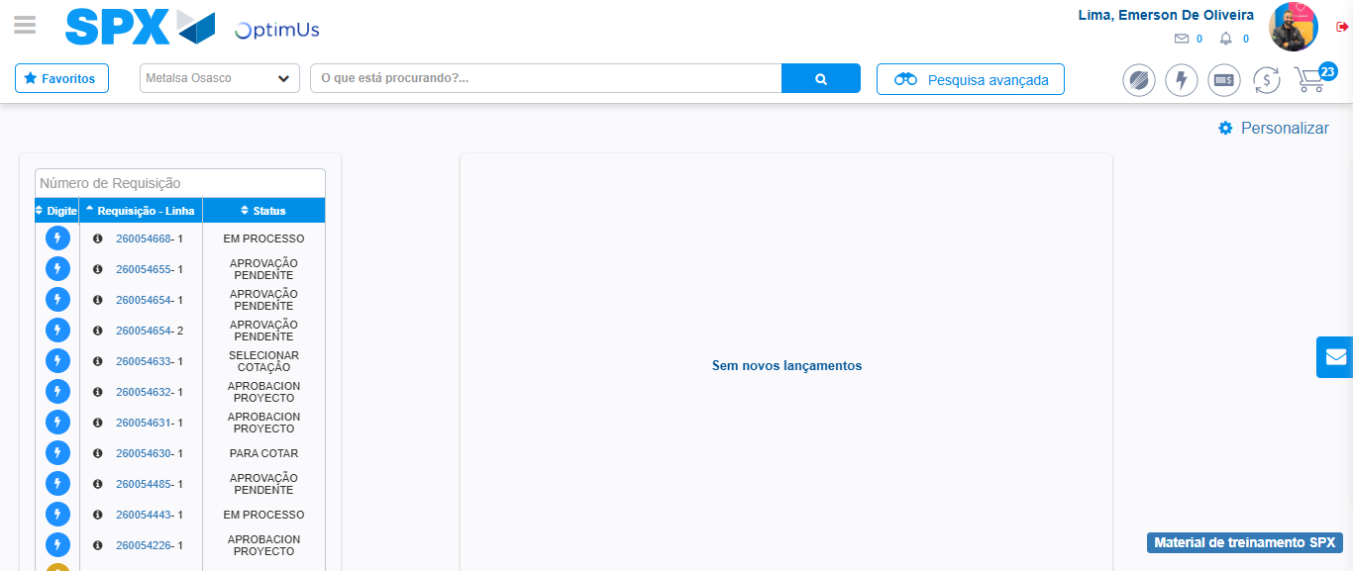Image file-name: QC_Testing-tc002_SPX_Dev5_Crear_Requisicion_Spot_Tipo_Cobro_Project-1785974742742

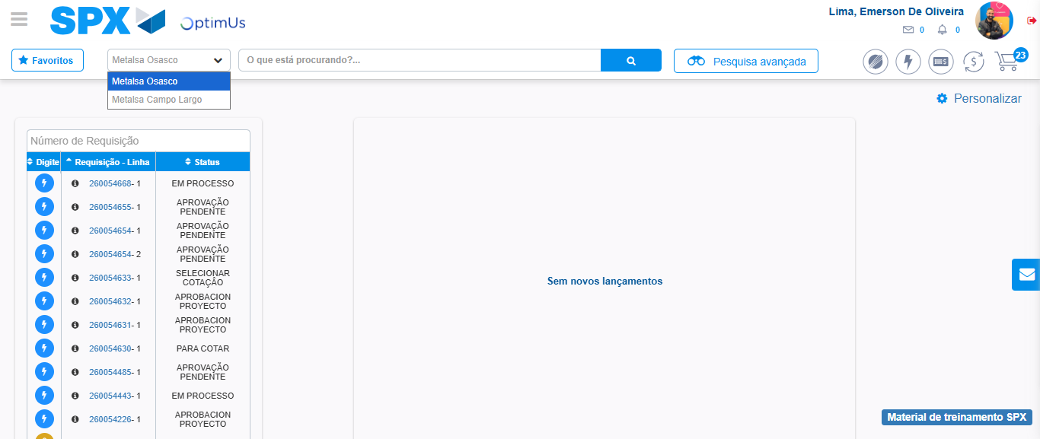Image file-name: QC_Testing-tc002_SPX_Dev5_Crear_Requisicion_Spot_Tipo_Cobro_Project-1785974745193

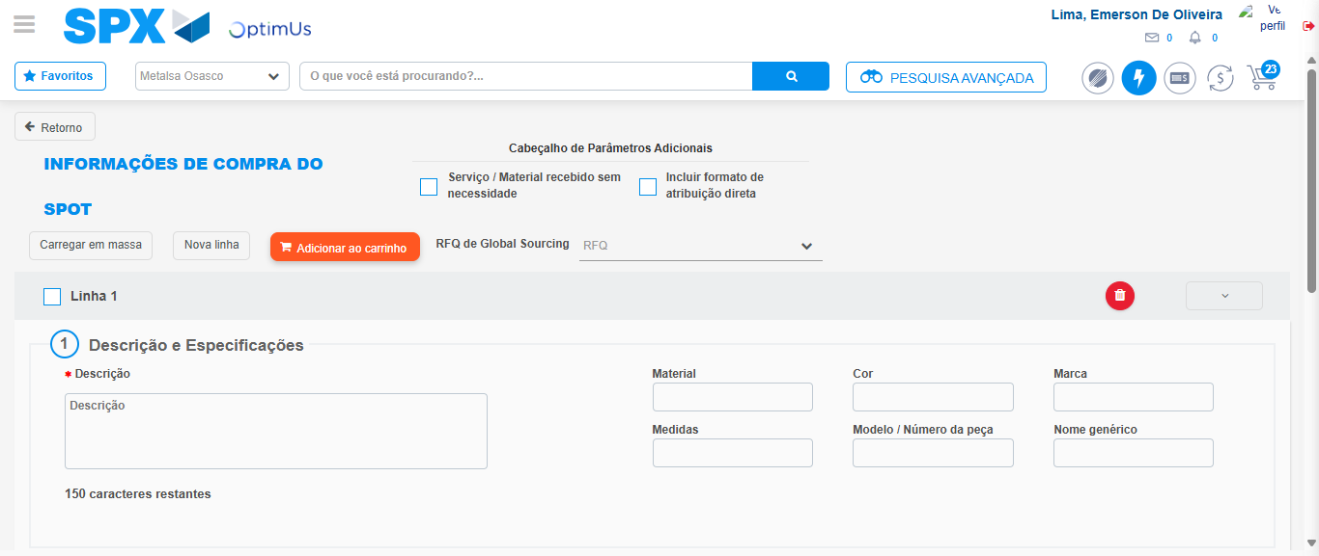Image file-name: QC_Testing-tc002_SPX_Dev5_Crear_Requisicion_Spot_Tipo_Cobro_Project-1785974750009

Step 3 - Data Capture Spot Buy Requisition: Data captured correctly
Image file-name: QC_Testing-tc002_SPX_Dev5_Crear_Requisicion_Spot_Tipo_Cobro_Project-1785974750242

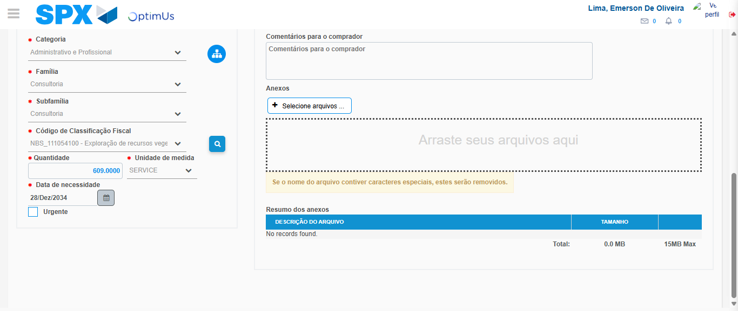Image file-name: QC_Testing-tc002_SPX_Dev5_Crear_Requisicion_Spot_Tipo_Cobro_Project-1785974770017

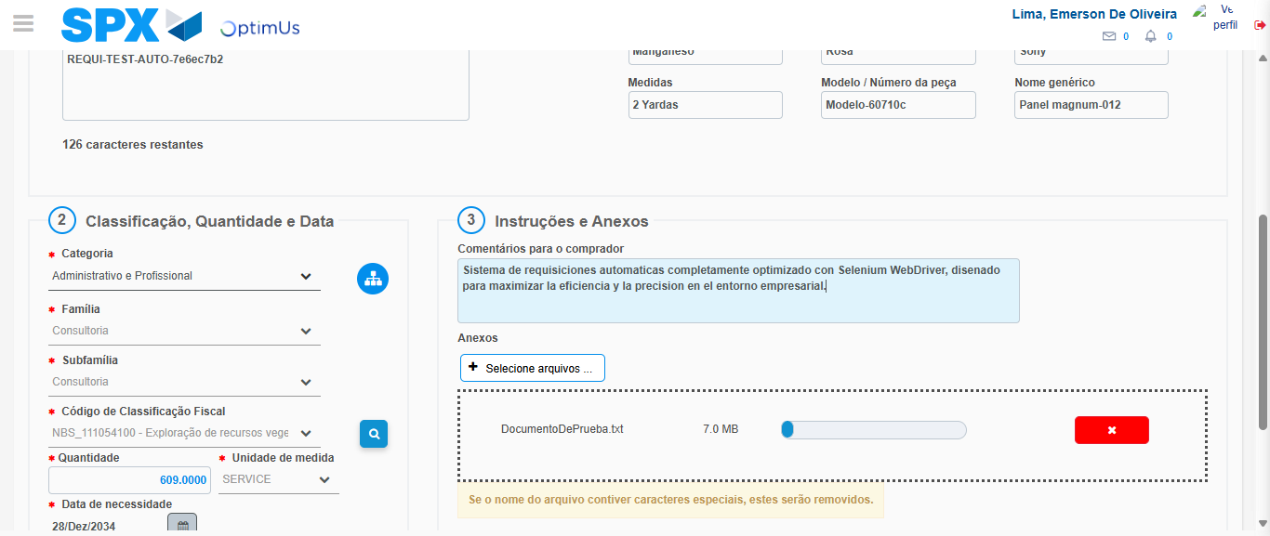Image file-name: QC_Testing-tc002_SPX_Dev5_Crear_Requisicion_Spot_Tipo_Cobro_Project-1785974770757

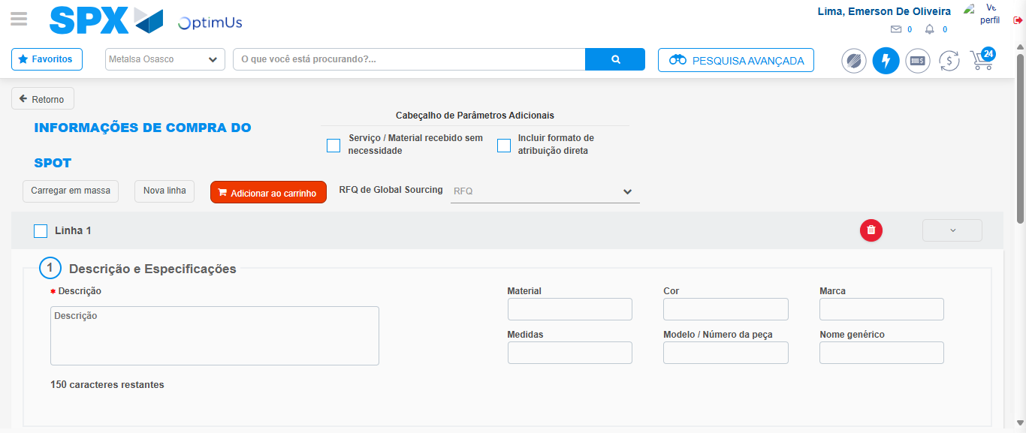Image file-name: QC_Testing-tc002_SPX_Dev5_Crear_Requisicion_Spot_Tipo_Cobro_Project-1785974775040

Step 7 - Return to Main Page SPX : Return to Main Page SPX
Image file-name: QC_Testing-tc002_SPX_Dev5_Crear_Requisicion_Spot_Tipo_Cobro_Project-1785974742742

Image file-name: QC_Testing-tc002_SPX_Dev5_Crear_Requisicion_Spot_Tipo_Cobro_Project-1785974745193

Image file-name: QC_Testing-tc002_SPX_Dev5_Crear_Requisicion_Spot_Tipo_Cobro_Project-1785974750009

Image file-name: QC_Testing-tc002_SPX_Dev5_Crear_Requisicion_Spot_Tipo_Cobro_Project-1785974777276

Image file-name: QC_Testing-tc002_SPX_Dev5_Crear_Requisicion_Spot_Tipo_Cobro_Project-1785974777459

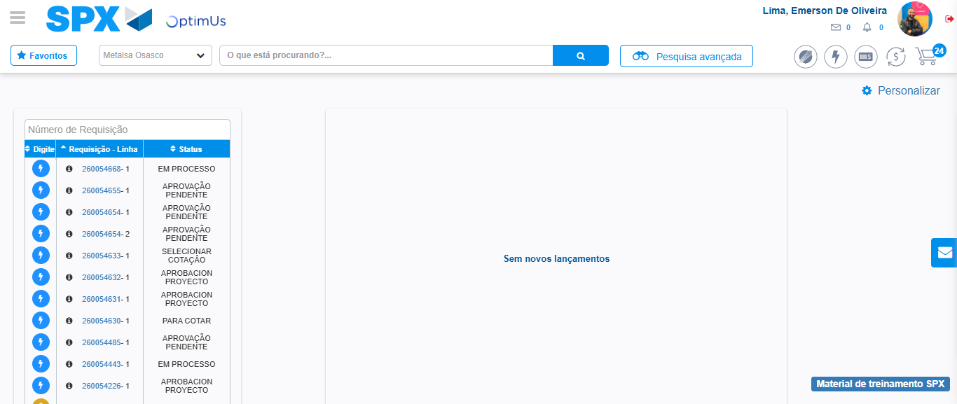Image file-name: QC_Testing-tc002_SPX_Dev5_Crear_Requisicion_Spot_Tipo_Cobro_Project-1785974798420

Step 8 - Log Out : Log Out SPX
Image file-name: QC_Testing-tc002_SPX_Dev5_Crear_Requisicion_Spot_Tipo_Cobro_Project-1785974798596

